ENG2DB Short Story Analysis Unit:
“The Necklace” by Guy de Maupassant
A Focus on Figurative Language
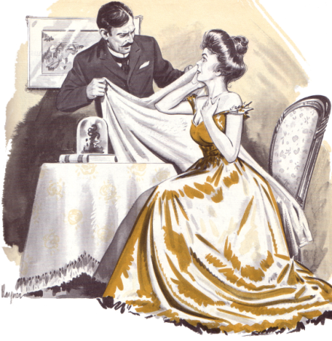
- Please identify each figurative language device listed below in the form of a direct quotation from the short story (be sure to cite these quotations correctly using MLA formatting), and complete the following FOUR analysis questions on a separate sheet of lined paper for EACH of the FIVE devices that are identified.

The Figurative Language List:
- Please find ONE specific example of each of the following figurative language devices from “The Necklace”, and quote it…

- Metaphor
- Simile
- Hyperbole
- Personification
- Imagery

The Analysis Questions:
- a) What is the purpose of this figurative language?
b) Is it used effectively? Why or why not? Explain in detail.

- Does the figurative language highlight something significant about the characters? Please explain.

- Does the figurative language help create a specific mood/atmosphere in the story? Discuss.

- Does the figurative language create a clear image in your mind as a reader? If so, how does this reinforce your understanding of the text?

