ENG1DB Short Story Analysis Unit: Examining Literary Elements in Wayson Choy’s “The Jade Peony”
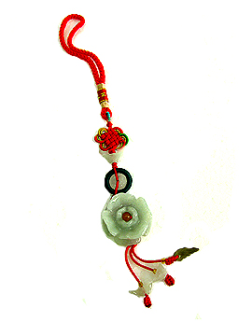
- Please respond thoughtfully to the following literary analysis, short answer questions.
- You must answer in complete sentences on a separate sheet of lined paper.
- Also, you are expected to follow a point/proof/analysis format when structuring your responses.
- Be thorough and insightful using direct proof from the short story (in the form of quotations) to support all of your assertions (points), and then provide an explanation (analysis) as to WHY your point and proof are significant to the story.

Literary Analysis Questions:

- Explain THREE reasons why the narrator is so fascinated by his grandmother, even referring to her as his “spiritual playmate”. Discuss each reason thoughtfully in connection with the story.

- What do you think the narrator means when he says, “It was the countless hours that I spent with Grandmama that were my real education”? Why is this time he spends with her his “real education”? Consider this insightfully.

- What are TWO significant character traits that the narrator demonstrates to readers through his own thoughts and/or actions in the short story? Discuss each characteristic critically.

- Identify and explain ONE example of situational irony found within the short story.

- Identify ONE central theme, and prove that it is developed effectively within the short story.

- A simile is a direct comparison between two unlike things using the words “like” or “as” within the comparison (i.e. Her eyes sparkled like a freshly-polished jewel or His snore was as loud as a freight train barrelling through a tunnel at full speed). Identify THREE different similes within the short story and discuss the PURPOSE and EFFECT of each example.

